

***DEPARTMENT OF COMPUTER SCIENCE & ENGINEERING,***

***SHARDA SCHOOL OF ENGINEERING AND TECHNOLOGY,***

***SHARDA UNIVERSITY, GREATER NOIDA***

**IOT BASED GASBOOKING AND SENSOR ALERT SYSTEM THROUGH SMS AND E-MAIL.**

***A project submitted***

***in partial fulfillment of the requirements for the degree of***

***Bachelor of Technology in Computer Science and Engineering***

**By**

**Vidushi Parashar (2019561219)**

**Tanya Bhadouria (2019620726)**

**Supervised by:**

**Dr. Vivek Sharma, Associate Professor Computer Science and Engineering**

**May, 2023**

**CERTIFICATE**

This is to certify that the report entitled “**IOT BASED GASBOOKING AND SENSOR ALERT SYSTEM THROUGH SMS AND E-MAIL**” submitted by Vidushi Parasher(2019561219) and Tanya Bhadouria(2019620726) to Sharda University, towards the fulfillment of requirements of the degree of Bachelor of Technology is record of bonafide final year Project work carried out by them in the Department of Computer Science and Engineering, School of Engineering and Technology, Sharda University. The results/findings contained in this Project have not been submitted in part or full to any other University/Institute for award of any other Degree/Diploma.

**Signature of Guide**

**Name:** Dr. Vivek Sharma

**Designation: Associate Professor (CSE)**

**Signature of Head of Department**

**Name:** Prof.(Dr.) Nitin Rakesh

**Place:** Sharda University

**Date**:

# Signature of External Examiner

# 

**ACKNOWLEDGEMENT**

A major project is a golden opportunity for learning and self-development. We consider our self very lucky and honored to have so many wonderful people lead us through in completion of this project.

First and foremost we would like to thank Dr. Nitin Rakesh, HOD, CSE who gave us an opportunity to undertake this project.

Our grateful thanks to Dr. Vivek Sharma for his guidance in my project work. Dr. Vivek Sharma, who in spite of being extraordinarily busy with academics, took time out to hear, guide and keep us on the correct path. We do not know where we would have been without his help.

CSE department monitored our progress and arranged all facilities to make life easier. We choose this moment to acknowledge their contribution gratefully.

Name and signature of Students

Vidushi Parashar (2019561219)

Tanya Bhadouria (2019620726)

**ABSTRACT**

The Smart Gas Kit is a recent technological advancement that has greatly improved the cooking experience for households using LPG. The kit leverages the Internet of Things (IoT) to monitor and display the amount of gas in a household LPG cylinder, while also predicting the remaining life of the gas. This system has been developed to address the common issues that people often face when using LPG for cooking, such as running out of gas during meal preparation, not knowing how much fuel is left, and not being able to predict when the cylinder will run out.

The Smart Gas Kit constantly measures the gas level using a load cell connected to a microcontroller, and sends notifications to the user via their mobile phone. This feature allows the user to monitor the gas level in real-time and plan their cooking accordingly, eliminating the need for manual monitoring which is often inaccurate and time-consuming. The system also predicts the remaining life of the gas, which helps the user to plan their cooking and prevent wastage.

The aim of the Smart Gas Kit is to make the LPG reservation process more automated and hassle-free. The kit is easy to install and use, and the user can use their mobile phone to receive notifications and monitor the gas level. This feature makes it accessible to a wide range of users, especially in developing countries, where LPG is often the primary source of fuel for households.

In conclusion, the Smart Gas Kit is a valuable technological innovation that has significantly improved the cooking experience for households using LPG. By leveraging IoT technology to monitor and predict the gas level in a household LPG cylinder, the kit eliminates the common issues that users often face when using LPG for cooking. The kit is easy to use and install, and it makes the LPG reservation process more automated and hassle-free. This innovation is particularly beneficial in developing countries where LPG is often the primary source of fuel for households, and the cost of LPG is high.

**CONTENTS**

TITLE. i

CERTIFICATE ii

ACKNOWLEDGEMENT iii

ABSTRACT iv

LIST OF FIGURES vii

LIST OF TABLES viii

CHAPTER 1: INTRODUCTION 9

* 1. Problem Statement

………………………………………………………………………………………………9

* 1. Project Overview

……………………………………………………………………………………………..11

* 1. Expected Outcome

……………………………………………………………………………………………..12

* 1. Hardware & Software Specifications

……………………………………………………………………………………………..13

* 1. Other Non-Functional Requirements

……………………………………………………………………………………………..14

* 1. Report Outline

…………………………………………………………………………………………… 14

**CHAPTER 2: LITERATURE SURVEY……………………………………………….15**

* 1. Existing gas leakage detection system …..………………………………………………..13
  2. Proposed System…………………………………………………………………………..22
  3. Feasibility Study…………………………………………………………………………..23

**CHAPTER 3: SYSTEM DESIGN & ANALYSIS ..........................................................25**

* 1. Project Perspective….……………………………………………………………………..25
  2. Performance Requirements………………………………………………………………..26
  3. System Features……………………………………………………………………………28

3.4 Methodology……………………………………………………………………………....30

3.5 Proposed Model Outputs………………………………………………………………….37

* 1. Design Templates…………………………………………………………….…………..38
  2. Components…………………………………………………………………………….. 39

**CHAPTER 4:RESULTS AND OUTPUTS……………………………………………...46**

* 1. Final product snapshot………………………………………………………………..…..46

**CHAPTER 5:CONCLUSION…………………………………………………………50**

* 1. System Usability………………………………………………………………………….51
  2. Future Scope…………………………………………………………………………….. 51

**CHAPTER 6: REFERENCES 52**

**ANNEXURE I**

**……………………………………………………………………………………….……53**

# LIST OF FIGURES

|  |  |  |
| --- | --- | --- |
| Fig 1.1 | Task performed by IOT based gasbooking and alert system through SMS and E-mail | 10 |
| Fig 1.2 | Block diagram | 11 |
| Fig 3.2.1 | Use case diagram | 27 |
| Fig 3.2.2 | ER diagram | 27 |
| Fig 3.3.1 | The working of IOT based gas booking and sensor alert system through SMS and a E-mail | 28 |
| Fig 3.3.2 | Workflow module | 29 |
| Fig 3.4.1 | The sensor detection model | 31 |
| Fig 3.4.2 | Detecting fire and gas leakage using sensors | 32 |
| Fig 3.4.4.1  Fig 3.4.4.2    Fig 3.4.4.3  Fig 4.2 | Web page and data maintenance  Web page and data maintenance    Web page and data maintenance    Semantic diagram | 34  35  35  40 |
| Fig 4.4.1  Fig 4.4.2 | Final Product snapshot    Final Product snapshot | 48  49 |
| Fig 4.4.3 | E-mail alert | 49 |
| Fig 4.4.4 | SMS alert | 49 |
| Fig 4.4.5 | Web page Login | 50 |
| Fig 4.4.6 | Web alert | 50 |
| Fig 4.4.7 | Web page data | 51 |

# LISTOFTABLES

Table 2.1.1 Survey Table 18

Table 4.3.1 Component Table 39

**CHAPTER 1**

**INTRODUCTION**

* 1. **Problem Statement**

During this peak period of technological advancement, every industry has been impacted by technology, and it has not only made our lives easier, but also provided safety and security in various fields, including medical and business. The Internet of Things (IoT), which allows hardware to be connected to the internet, has become an essential technology used in many different areas, including homes. LPG fuel is widely used in many industries due to its versatility, and petroleum companies have introduced customer-friendly technology such as text message ordering and interactive voice response. However, consumers often have difficulty estimating how much LPG is left in their cylinders, causing inconvenience when the gas runs out. Therefore, there is a need for an IoT system to automatically measure the gas level and alert the user when it is time to purchase a new cylinder. In India, the most used cooking fuel is liquefied petroleum gas (LPG). In addition to being affordable and accessible, LPG is a great fuel for cooking. Given the rise in the use of this fuel, it is important to establish specific safety requirements that must be followed in order to live a life free of accidents. The most significant LPG-related accident occurs as a result of harmful gas leakage. Gas cylinders, which are used in practically every Indian household, are prone to gas leaks. The ageing gas pipelines are another potential source of gas leak since they frequently degrade and may eventually explode. The use of LPG (Liquified Petroleum Gas) for cooking is widespread across households and businesses due to its affordability, accessibility, and versatility.

However, running out of LPG during peak cooking hours can cause major inconveniences and delays in meal preparation. In addition, gas leaks can pose a serious safety hazard and lead to accidents such as fires or explosions. To address these challenges, there is a need to develop an IoT-based LPG gas booking and sensor alert system that can continuously monitor the LPG cylinder's weight, detect gas leaks, and provide real-time alerts to the user via SMS and email. The IoT technology allows hardware devices to be connected to the internet, enabling data collection, analysis, and automation. By incorporating IoT technology into LPG gas management systems, it becomes possible to automate the gas booking process and provide real-time alerts for gas leaks. This solution has several advantages over traditional manual methods of managing LPG gas supply and usage.

Firstly, an IoT-based system can provide a convenient solution for managing LPG gas supply and usage. By continuously monitoring the weight of the LPG cylinder and setting a threshold value for automatic booking, the system can prevent users from running out of gas during peak cooking hours. This can save time and effort, especially in households with busy schedules. Secondly, an IoT-based system can provide a safe solution for managing LPG gas supply and usage. By installing sensors to detect gas leaks, the system can alert the user in real-time via SMS and email. This can reduce the risk of accidents and improve safety standards in households and businesses. Thirdly, an IoT-based system can provide an efficient solution for managing LPG gas supply and usage. By automating the gas booking process, the system can reduce the workload of the user and increase the efficiency of the LPG supply chain. This can also benefit LPG gas distributors by enabling them to optimize their delivery schedules and improve customer service.

In India, where LPG is the most widely used cooking fuel, there is a need to establish specific safety requirements to prevent accidents related to gas leakage. An IoT-based LPG gas booking and sensor alert system can help to meet these safety requirements by providing real-time alerts for gas leaks and automating the gas booking process. This can improve the safety and efficiency of the LPG supply chain in India and benefit millions of households and businesses. The development of an IoT-based LPG gas booking and sensor alert system through SMS and email tool can provide a convenient, safe, and efficient solution for managing LPG gas supply and usage. The incorporation of IoT technology into LPG gas management systems can help to prevent accidents related to gas leakage and optimize the LPG supply chain. With the rise in technological advancements, it is crucial to embrace new technologies and implement them in ways that benefit society. An IoT-based LPG gas booking and sensor alert system is a step in the right direction towards achieving this goal.

Fig 1.1. Task performed by IOT based gasbooking and alert system through SMS and E-mail

* 1. **Project Overview**

We are developing an IOT-based project that will assist us in resolving the LPG gas shortage and leakage issues we face on a daily basis. This product will be installed in homes or other structures and connected to the LPG gas cylinder, where it will monitor for fires and the running out of LPG cylinders as soon as smoke is detected.

The system includes-

* + 1. DETECT GAS LEAKAGE – it is done using gas detection sensor. if it finds any gas leakage it automatically activate the buzzer and display on screen.
    2. DETECT FIRE – if cylinder is not empty and fire sensor detects any fire it activate the buzzer.
    3. DETECT CYKINDER STATUS- if cylinder is empty SMS and email is send and is display on the screen.
    4. SMS AND E-MAIL ALERT- all the detection alert are sent to the user register number through mail and SMS.

The MQ-6 sensor is used to detect gas leaks, and the Arduino Uno Microcontroller is the brain of the Gas Leak Detector. It controls every aspect of the circuit. The system's fundamental block diagram is shown as follows:

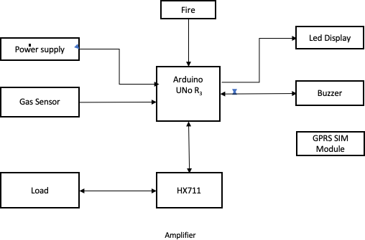

Fig 1.2 Block diagram

* 1. **Expected Outcome**

The method that was suggested looked at many factors relating to the technology employed for gas level sensing. It began with an explanation of the problems encountered and the difficulty brought on when an LPG cylinder runs out while being used for cooking. This result shows that while the various technologies were expensive, they had the same mindset. Designing a straightforward and workable strategy to address the issue was crucial. The user-friendly gas level detection system that was suggested and successfully implemented as a result of the use of IOT also provides a method for determining the current quantity of gas left in the cylinder and forecasting the working days. By using this technique, any inconveniences caused by cylinder booking delays are avoided.

Below are the points that we can expect from this project-

1. Explanation of the problem encountered when an LPG cylinder runs out while being used for cooking
2. Discussion of the factors relating to the technology employed for gas level sensing
3. Explanation of the various technologies available and their expense
4. Designing a straightforward and workable strategy to address the issue
5. Suggestion of a user-friendly gas level detection system utilizing IOT
6. Successful implementation of the gas level detection system
7. Use of the system to determine the current quantity of gas left in the cylinder and forecasting the working days
8. Avoidance of inconveniences caused by cylinder booking delays
   1. **Hardware & Software Specifications**

**Hardware Specifications**

* + - Laptop/Desktop that supports Windows / MacOS / Android OS / iOS or any other, with minimum 2GB RAM
    - GSM SIM 800L
    - power supply board
    - bridge rectifier
    - filter capacitor
    - 7805 voltage regulator
    - Mq2 gas sensor
    - 16x2 lcd display
    - fire sensor
    - Max232 IC
    - Busser
    - Level convertors
    - Hx711 module
    - Load cell

**Software Specifications**

* Arduino UNO R3
* Embedded C language
  1. **Other Non-Functional Requirements**

#### **Hardware Quality Attributes**

* Availability: Its made at a very budget friendly cost and it can be made available for any kind of user (Home, Factories, Industries, etc.) anywhere, where LPG gas cylinder automation is needed.
* Correctness: It always shuts down the motor with a 99.4% accuracy rate, as risk of failure is very minimal because it works on circuit breaking mechanism.
* Maintainability : The user should maintain the module by cleaning and servicing regularly.
* Usability: It can be installed anywhere where there is a water tank, it is very budget friendly product so that common people can afford it easily and it is very easy and convenient to install the product in the existing water supply system.
  1. **Report Outline**

Chapter 2 focuses on the previous work done to highlight the existing applications in the automation industry which make use of IoT.

Chapter 3 focuses on the proposed model, how it proceeds, what are the requirements, who are the users and what all will be the methodology to build our solution.

Chapter 4 provides the results and experimental analysis of our system.

Chapter 5 finally concludes the whole paper and talks about the future scope of the proposed system.

**CHAPTER 2**

**LITERATURE SURVEY**

**2.1 Existing gas leakage detection systems**

Several techniques have been created to estimate the gasoline quantity in a cylinder and schedule its booking. One such method involves measuring the gas level within the cylinder using the pressure sensor built into the RFID. The output from the pressure sensor was fed to a PIC controller, which stored a voltage proportional to the gas weight. The controller's output was displayed on an attached LCD screen, providing the user with the same information. The controller was programmed with a threshold value, and once this value was reached, the voltage output was sent to an alarm, which alerted the user. [1]

The study involved determining the liquid level inside a container by measuring the tonal frequencies created when tapping on the container's outer surface. To test the method's effectiveness on a complex but feasible cylinder design, a detailed model based on the Euler-Bernoulli beam theory was developed. The results show that the experimental data and theoretical analysis are consistent with each other. The study indicates that the proposed model can accurately describe how vibratory frequencies behave at different liquid levels. Therefore, the device can effectively detect when a gas cylinder is almost empty, enabling automatic monitoring. [2]

Various instruments, such as Pitot tubes, operate by comparing the pressure in a small-diameter tube (impact pressure) with the surrounding static pressure. In the case of gas flow measurement, equipment is used to detect the pressure inside the cylinder. The Venturi pressure is measured before and after a constriction, and the flow rate is then estimated by calculating the difference between the two readings. Another trustworthy method for measuring flow is orifice plates, which can be easily replaced by a technician to achieve the desired pressure differential for different flow rates. [3]

Kumar Keshamoni and Sabbani Hemanth have developed a system for monitoring gas levels, booking refills, and tracking gas usage. The system utilizes IoT sensors to continuously monitor the gas levels and send notifications to the appropriate branches for cylinder replacement. To make the system user-friendly, a radio frequency module is used, which includes a transmitter and a receiver kit. The decoder kit is fixed in the sub-board of the receiver, while the encoder kit is fixed in the main board of the transmitter. The advantage of this system is that it is easy to use and provides accurate information. Additionally, a temperature sensor is employed to detect errors caused by environmental factors. However, the system has some limitations, including the use of a CPU instead of a controller and the absence of user security measures. [4]

Gas leaks are considered a severe issue as they can lead to damage of property and injury to humans. Neglecting equipment maintenance and unawareness among the public are the primary causes of gas leaks. Therefore, it is imperative to detect LPG leaks to prevent accidents and protect lives. This study presents a method for identifying and notifying individuals about LPG leaks. The system triggers an LED and buzzer to alert people when it detects a gas leak. The method is simple and reliable. [5]

A sensor-based automated gas leakage detector system, complete with a warning and control system, has been introduced. Detecting gas leaks is critical for both public health and economic growth, as gas leaks not only pollute the environment but also result in wasted gases, which can be detrimental to business. [6]

Individual bottles of butane, used for cooking and camping, are equipped with a highly sensitive alarm system. This system is designed to emit early warning signals during less severe conditions and to sound a loud alarm in emergency situations. The system has been developed in accordance with the occupational health and safety regulations in the UK. [7]

LPG is highly combustible and can ignite even at a distance from the leak location, leading to accidents. Inadequate regulator shutdown or usage of substandard rubber tubing is often responsible for such incidents. A DC motor, driven by a relay, regulates the stove knob automatically in this system. Furthermore, the cylinder is automatically refilled, which is a useful feature. [8]

Serious disasters causing both monetary losses and harm to humans can occur due to gas leaks. In order to take corrective action, it is important to not only know that a leak exists, but also to locate it. Several techniques have been developed for gas leak detection and localization, and this paper aims to describe the most up-to-date ones. [9]

The Look Dream Wireless 433 MHz Gas Leakage Detector is a security system device that can detect dangerous gases. [10] It alerts the user when the gas density reaches a preset value, determined by the surrounding atmosphere, by sounding an alarm in a cautionary state. Once the alarm sounds, the gas density usually decreases and returns to a safe level. The device then sends the user the current gas density reading and continues to operate in the same manner, automatically obtaining counter readings from the user who installed it.

The alarm consists of three signal bulbs that indicate different statuses using the colors green, yellow, and red in a discreet manner:

1. Green Light: This signifies that the alarm is operating normally and is in a controlled state.
2. Red Light: This indicates a critical status of the alarm and emits a loud sound.
3. Yellow Light: This signals a problem with the transducer and indicates that the alarm is not functioning properly.

The system [11] is responsible for detecting and halting the supply of harmful gas or liquid leaks, and it is entirely electronic. This means that it is an electronic system that identifies harmful gas or liquid leaks electronically and then broadcasts the information as an electronic signal. It then collects this signal and activates a system that blocks the gas or liquid leakage regulator electronically. This system does this every time there is a harmful gas or liquid leak.

On the other hand, a gadget [12] is designed to identify LPG (liquefied petroleum gas) leaks and alert users via SMS, suspend power delivery in emergency situations, and sound an alarm. Additionally, the system continuously monitors the amount of LPG in the gas cylinder using a load sensor. Once the amount of LPG reaches the threshold limit of 2 kg, the system allows the user to purchase a new cylinder at the appropriate time and can automatically order it through the GSM module. [13] This mechanism ensures safety and prevents suffocation and explosion resulting from LPG leaks.

Table 2.1.1 Pre-existing applications

|  |  |  |
| --- | --- | --- |
| S.NO | Name | How they use IOT technology |
| 1. | Gas Leak Detector using Arduino UNO Microcontroller | Various methods for calculating the gas left in the cylinder planning its booking have been developed. In this system the gas level within the cylinder was measured using the RFID's built-in pressure sensor. The PIC controller, which stores the voltage proportional to the gas weight, received the output of the pressure sensor. The LCD, which was attached to the output of controller port, showed the same information. The controller was programmed with a threshold value. The value of voltage was provided by the alarm after the threshold level was achieved, alarming the user. [1] |
| 2. | ROUTING TECHNIQUES IN WIRELESS SENSOR NETWORKS | In the investigation, the liquid level within the container was determined using the tonal frequencies produced while pounding on the container's exterior surface. To investigate the viability of the technique for a cylinder with a complex but feasible construction, a thorough model based on Euler-Bernoulli beam theory was developed. These results demonstrate that data experimented and the theoretical analysis are in good agreement. The findings show that the suggested model can adequately describe how vibratory frequencies behave under various levels of liquid. The device may be successfully used to detect the gas cylinder's almost empty state automatically. [2] |
| 3. | A SECURITY ALERT SYSTEM USING GSM FOR GAS LEAKAGE | Different equipment, like Pitot tubes, function by contrasting the static pressure around the tube with the pressure within a small-diameter tube (impact pressure). Flow of gas is measured by device that were used to detect pressure in the cylinder. Prior to and halfway through a constriction are measured for Venturi pressure, and the flow rate is then estimated from the difference between the two readings. A reliable flow measuring method is orifice plates. Because orifice plates are replaceable, a technician may adjust the orifice plate size to create the necessary pressure difference with various flow rates.. [3] |
| 4. | Smart LPG  Monitoring and Automatic Booking System using IOT | The reasonable Gas Level observation, Booking, and Gas outflow were planned by Kumar Keshamoni and Sabbani Hemanth. Detectors are IoT victims. The gas level in the instrumentation is continuously checked throughout this time, and it also notifies the various branches where to place the new LPG cylinder. The transmitter and receiver kit are part of radio frequency unit, which is used to make it simple for the user to use. The decoder kit for the receiver is fixed in the sub board, while the encoder kit for the transmitter is fixed in the main board. Its benefit is that it provides the same information and is simple to use. The temperature sensor is also employed to identify mistakes brought on by environmental factors. This system's primary problem is that the CPU is utilised rather than the controller, and there is also no user security. [4] |
| 5. | LPG Gas Leakage Detection and Alert System | Gas leaks are dangerous accidents that damage property and hurt people. The main causes of gas leaks are poor equipment maintenance and a lack of public awareness. It is essential to locate LPG leaks in order to prevent accidents and save lives. This research provided instructions for finding and notifying people about LPG leaks. This device triggers an LED and a buzzer to alert people when it detects an LPG leak. It is quite simple and reliable to use this method. [5] |
| 6. | Sensor-Based Gas Leakage Detector System | An warning and control system-equipped sensor-based automated gas leakage detector has been presented. Not only will gas leak detection be important for health, but it will also help our economy to grow since gas leaks not only contaminate the atmosphere but also waste gases, which is bad for business. [6] |
| 7. | Design and  Implementation of an Economic Gas Leakage Detector | As a cooking and camping fuel, butane is also sold in individual bottles and has a high sensitivity alarming system. When conditions are less severe, it sends out early warning signals, and when an emergency arises, it sounds a loud alarm. The suggested method is made to comply with safety and health at work regulations in the UK. [7] |
| 8. | C-Leakage: Cylinder LPG Gas Leakage Detection for Home Safety | LPG is highly flammable, therefore it can burn even some distance away from the spill. Most mishaps occur when the regulator is not switched off or when the rubber tubing is of low quality. A relay-driven DC motor automatically controls the stove knob. The technology also offers the advantage of rebooking the cylinder automatically. [8] |
| 9. | A survey on gas leak detection and localization techniques | Gas leaks can result in serious catastrophes that inflict both financial losses and human damage. Some techniques for finding leaks were created to give the possibility of locating the leak because simply knowing there is a leak does not always allow for the launch of a corrective action. This paper's goal is to outline the most recent techniques for leak localization and detection. [9] |
| 10. | Recent advances in fire detection and monitoring systems: A review | Look dream Wireless 433 MHz Gas Leakage Detector for Security Systems [10] is used for dangerous gas. This gadget detects when the gas density reaches the preset |
| 11. | A Review on Microcontroller based LPG Gas Leakage Detector | A system called the "Integrated remote control gas leakage detection and shut-off system" [11] detects harmful gas and/or liquid leaks and instantly cuts off the supply. This system is entirely electronic, which indicates that it is an electronic system. When a harmful gas or liquid leak occurs, this system electronically recognises the situation, broadcasts the information as an electronic indicator, collects the electronic indicator, and then electronically starts a system that blocks the gas or liquid leakage regulator. This system does this whenever a  harmful gas or liquid leak occurs. |
| 12. | Gas Leakage Detector and Monitoring System | The gadget "A wireless LPG leakage monitoring system"  [12] is designed to detect LPG (liquefied petroleum gas) leaks, notify users by SMS of these leaks, and then automatically suspend power delivery in emergency disaster situations while sounding an alert. As an added feature, this system continually keeps an eye on amount of  Using a load sensor, LPG is detected in the gas cylinder. |
| 13. | Protection from Leakages of Gas from LPG Cylinders | When the amount of LPG reaches the 2 kg limit, which is less than the threshold, it allows the person (user) to purchase a new cylinder at the appropriate time and can robotically order it via GSM module. [13] This mechanism ensures protection and prevents suffocation and detonation brought on by LPG leaks. |

**2.2 Proposed System**

The proposed system has been designed to address a particular problem by overcoming the limitations of the current system and incorporating new features such as real-time gas level sensing and weight measurement. The system employs an Arduino UNO and SIM module for networking and utilizes a moveable trolley to hold the gas cylinder with a load sensor attached to it. The weight data from the sensor is sent to an hx711 amplifier, and when the weight falls below a specific limit, the user is immediately alerted via SMS and email to reserve a new cylinder.

Additionally, the system uses a MQ2 gas sensor to detect gas concentration levels and alerts the user when it exceeds a preset limit. This solution is not only useful for detecting gas leaks but can also be used by LPG users for multiple purposes.

To detect gas leaks, the MQ2 sensor is connected to an Arduino, which activates an alarm and displays an alert on the LCD screen when a leak is detected. The system also sends SMS and email notifications to the user's registered mobile number and email address. Moreover, the system uses a load cell to measure the gas weight and displays the result on the LCD screen. When the cylinder's weight falls below a specific level, the system immediately alerts the user to order a replacement cylinder and sends the notification to the customer through a GSM module.

Overall, the proposed system is an innovative solution to the problems associated with the current gas cylinder management system. It incorporates real-time gas level sensing, weight measurement, and gas leak detection features, which help users manage their gas cylinder usage more efficiently. The system's use of technology, such as the Arduino UNO and SIM module, load sensors, and MQ2 gas sensors, is a significant improvement over the current manual system. The system's ability to send timely alerts to users ensures that they never run out of gas unexpectedly and can always order a replacement cylinder in advance.

Moreover, the gas leak detection feature adds an extra layer of safety for users, giving them peace of mind that they will be alerted in case of a leak. The use of a load cell to measure gas weight is also a crucial feature that ensures users can keep track of their gas usage accurately.

In conclusion, the proposed system is a sophisticated solution that addresses the limitations of the current gas cylinder management system. The system's incorporation of real-time gas level sensing, weight measurement, and gas leak detection features ensures that users can manage their gas cylinder usage efficiently and safely. The use of technology, such as the Arduino UNO and SIM module, load sensors, and MQ2 gas sensors, sets the system apart from the current manual system and makes it an innovative and effective solution.

**2.3 Feasibility Study**

The products that are available in market are expensive, making them challenging for regular people to purchase for their homes. Furthermore, they have complex mechanisms and multiple components, resulting in high electricity consumption. Our product, on the other hand, addresses these issues and saves users from such problems

The feature that our product offers are-

* **Simple and User Friendly →** Our product simply sits with the main submersible console and fits without any custom modification.
* **Checks for system security and all connections before proceeding→** Once the user decides to install the kit and starts it firstly it checks all the connection and then only it proceeds to work . This function of the system provides us security form any loose ends and protects us from any dangerous miss happening.
* **Fire and gas leakage detection and alert system –** the system checks for any fire or gas leakage and if it is found it alerts the user through alarm and notifications by sending SMS and E-mail on the users mobile. It also notify the users about the low level of gas left in gas cylinder to pre- book to avoid interruption .
* **Our model →** The proposed model is prepared in such a way that can be used for home automation, and it can be installed anywhere . Our system not only helps to detects gas leakage and fire but also alert the user about the low gas level through SMS and E-mail .

Thus, in this way, our product overcomes the problems faced by any other products in the existing systems.

**CHAPTER 3**

**SYSTEM DESIGN & ANALYSIS**

**3.1 Project Perspective**

This project utilizes advanced IoT technology to monitor LPG gas levels and detect potential hazards like gas leaks or fires, taking appropriate actions to prevent accidents or damage. The system operates even when the user is not present and can send notifications to their mobile device. The module is designed to prevent LPG gas wastage, maximizing the use of available gas while preventing leaks or wastage, reducing consumption, associated costs, and environmental impact. Overall, the project provides an innovative and effective solution for households using LPG gas for cooking and heating, ensuring safety and promoting sustainable practices.

This project focuses on some points given billow-

* The project uses advanced IoT technology to operate even in the absence of the user.
* The system monitors the LPG gas level in real-time and detects any fire or gas leakage, taking appropriate action.
* The system is designed to save LPG gas and prevent wastage through efficient design and functioning.
* The IoT technology used in the project is highly advanced and provides timely notifications to the user's mobile phone or connected device.
* The module maximizes the use of available gas and prevents leaks or wastage, reducing overall consumption and associated costs and environmental impact.
* The project is an innovative and effective solution for households using LPG gas for cooking and heating, ensuring safety and promoting sustainable practices.

**3.2 Performance Requirements**

**3.2.1. Use Case Diagram**

Understanding the number and the functionality of the project is the first step. Before proceeding further, we must know the functionality of the system. Figure 3.2.1 shows the use case diagram of the project. It can be seen from the use case diagram in that there is mainly a single user who only switches on the LPG gas kit for once and after that all the other actions are taken care of by the IOT BASED GASBOOKING AND SENSOR ALERT SYSTEM THROUGH SMS AND E-MAIL.

• **End user:** The user should be able to do the following functions:

* + Electricity supply for module to work
  + All safety measures should be checked
  + Switch on the Console
  + Track the performance from in case of any error
* **IOT BASED GASBOOKING AND SENSOR ALERT SYSTEM THROUGH SMS AND E-MAIL system:** The module should be able to do the following functions:
* It should be able to detect the sensors.
* It should detect the gas level and send notification as by the sensors readings.
* It should also detect the any fire or gas leakage and send SMS and E-mail accordingly.
* It should also allow the user to maintain the data on web page.

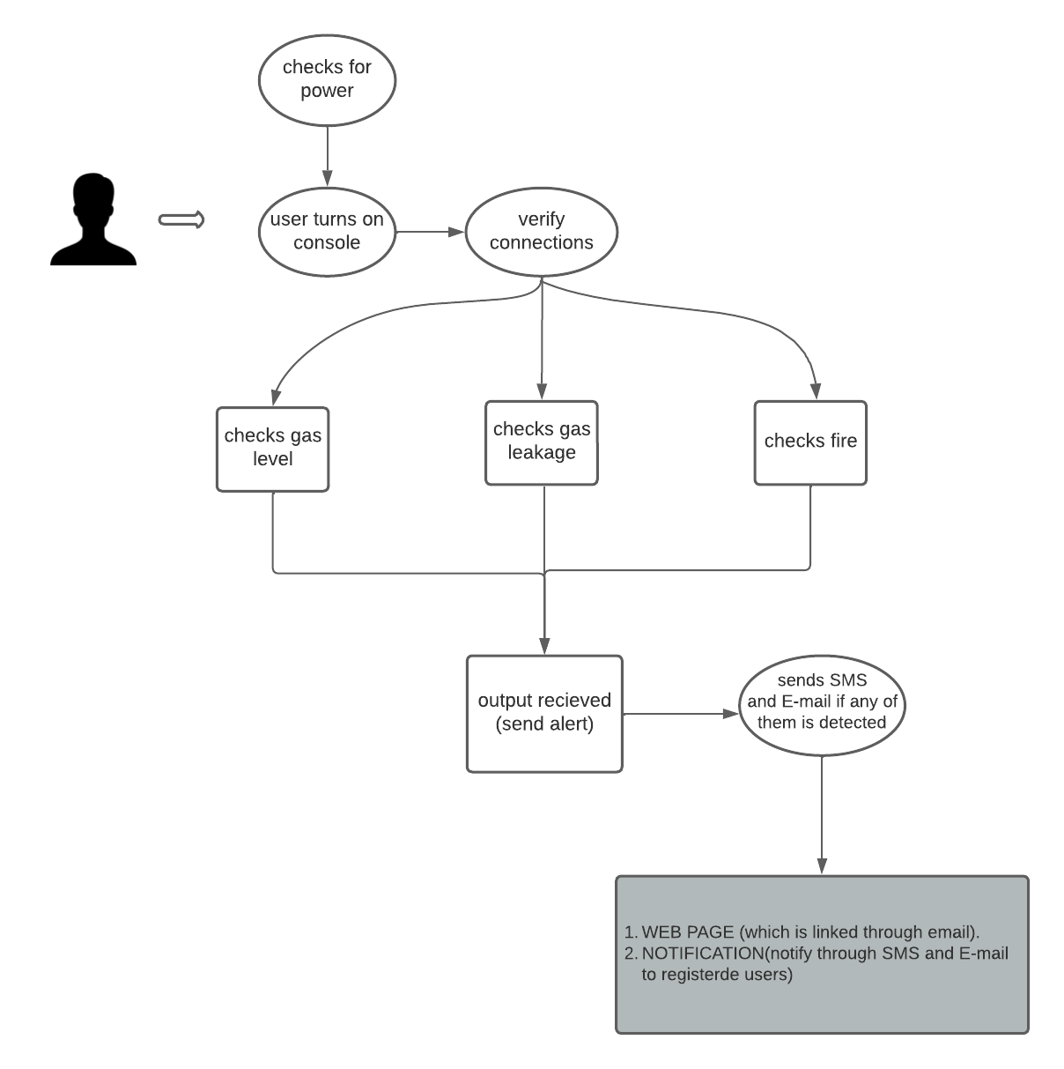

Fig 3.2.1 The use case diagram

**3.2.2 ER Diagram**

Database plays a crucial role in any project. Therefore, understanding the structure of the database becomes an important step. Below figure shows the ER diagram of our project. There are three entities, Users, Tank and motor, where User is linked with all the other entities.

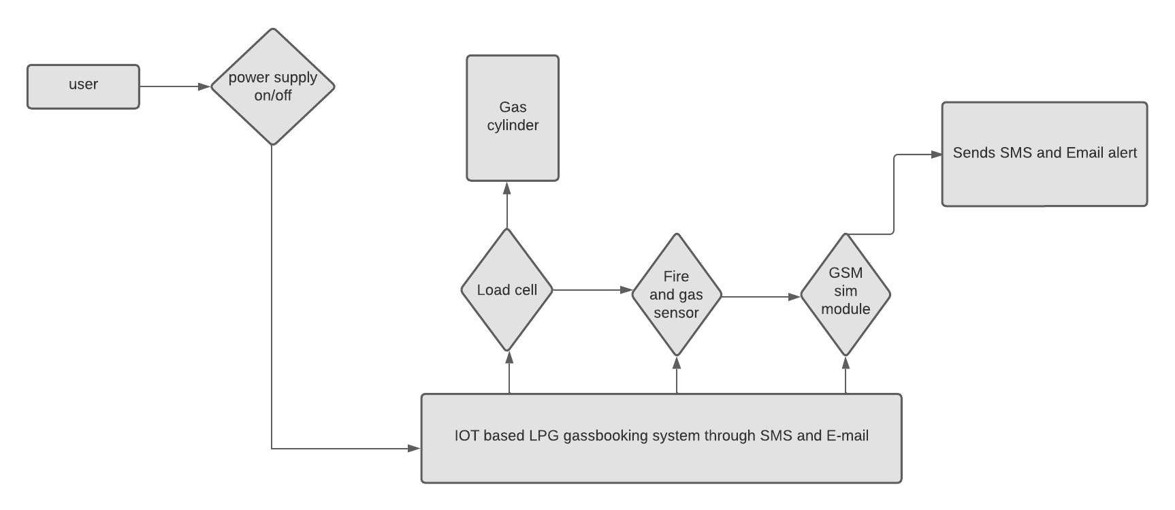

Fig 3.2.2 The ER diagram

**3.3 System Features**

**3.3.1 Gas level detection session**

The primary characteristic of the project is the automated aspect of the product, which centres around the communication between the LPG gas detection and alert system and the primary operating console. As a result, comprehending the system’s workflow and its execution becomes essential.

In this system, user only needs to just initiate the process, i.e. The user only needs to switch on the main console which operates the system. After that the IOT BASED GASBOOKING AND SENSOR ALERT SYSTEM THROUGH SMS AND E-MAIL system

comes into action where it checks the gas level in cylinder and operates accordingly. If the gas level is low sensed by the sensor the system will automatically activates the busser and send notification to the user through SMS and E-mail to the registered number and mail.

The product can be used in the following cases:

* Whenever the user wants to reserve the gas cylinder in advance
* Whenever the user wants to check whether the level is high or low.



Fig 3.3.1 The working of IOT based gasbooking snd sensor alert system through SMS and a E-mail

#### **Multifunctional Module.**

Another most astonishing feature of this is as it also detects gas level present in cylinder and detects any fire or gas leakage and alert the user about the same through SMS and E-mail and also activates the busser. Therefore, it becomes necessary to understand the workflow of the system and its implementation. This feature can be accessed in the following cases:

* Whenever the user forgets to switch off the main console
* Whenever the user wants the system to be fully autonomous.

Once the user chooses to switch on the console, the system functions in the sequence as shown in the figure 3.3.2.

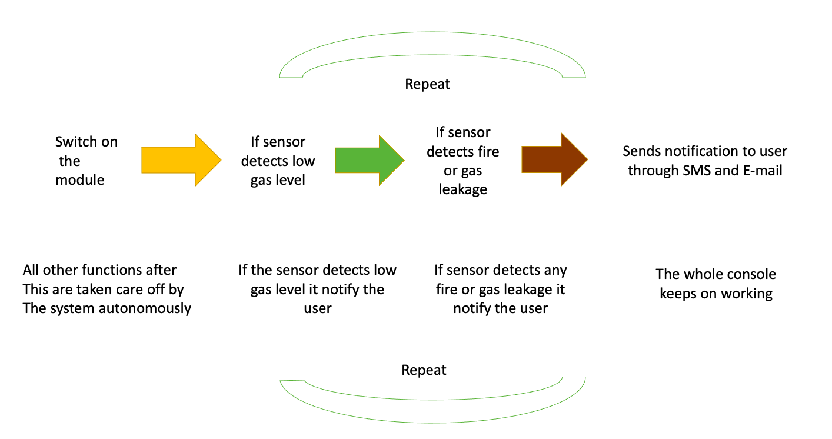

Fig 3.3.2. Workflow of module

The product offers a fully integrated peer-to-peer connection between all types of systems, ensuring that all functions are managed seamlessly. When the user turns on the console, IOT BASED GASBOOKING AND SENSOR ALERT SYSTEM THROUGH SMS AND E-MAIL system takes care of all subsequent functions . This system eventually help us to solve the problem of LPG gas wastage in household and due to carelessness. The techniques that we have used to make this product are so cost efficient and may lead it to become a product which will be more cost effective for a common buyer.

### **Methodology**

* + 1. **Gas level detection cycle**

A gas level detection cycle involves two important things , viz.

* 1. Switching on all the module while checking the sensor and
  2. Sending alert messages and E-mail at the right time once the gas level below the threshold value is detected .

The detailed working are mentioned below.

**LOW GAS LEVEL DETECTION MODEL:** for the low level detection model, we use two sensor which are also known as load cell and load amplifier sensor will be placed on a trolly on top of which the gas cylinder will be placed.

The gas level detection model works as follows:

1. When the user switches on the console, firstly it checks for all the connections are safe or on and make sure the working of all components in itself.
2. Once all the connections are checked the console sends signals to the gas level detector sensor which is also known as load cell.
3. If the sensor detects low gas level it will alert the user through SMS and E-mail and will also send a web link on their mail id which will direct them to the web page where they can also see the whole data .

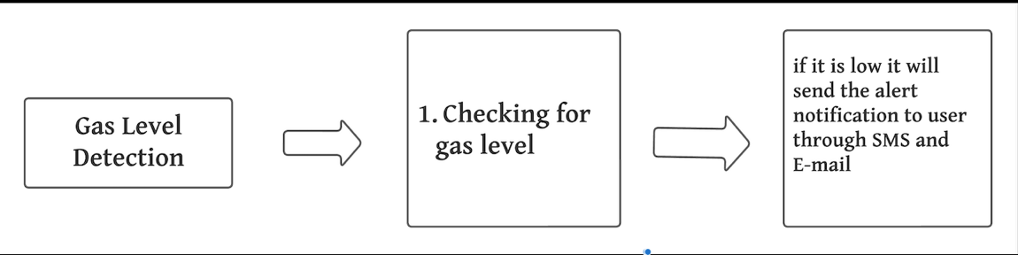

Fig 3.4.1 The sensor detection model

* + 1. **DETECTION TOOL:**

For leakage detection it is necessary to have a bunch of sensor that are integrated together to make this module successfully working. For the same we have used two sensors fire detection sensor and gas leakage detection sensor. The integrity of these two sensors makes the module work flawlessly.

For example, consider the example of a house where the system is fitted,

* The user switches on the gas and by any cause they forgot to switch it off.
* The automated system will detect the gas leakage , and if found it will alert the user by activating the busser and by sending SMS and E-mail to the users registered mail id and phone number.
* If any fire detected around the system then also it will alert the user by using busser and notifications like SMS and E-mail .
* So, the gas level analysing sessions only wants the user to choose to switch on the console all other actions are controlled by the IOT BASED GASBOOKING AND SENSOR ALERT SYSTEM THROUGH SMS AND E-MAIL system afterwards.

Once the console is started , the IOT BASED GASBOOKING AND SENSOR ALERT SYSTEM THROUGH SMS AND E-MAIL system does step by step process adequately.

1. Checks for all the connections before starting the session.
2. Stablish network through GSM sim module to send SMS and E-mail.
3. Detects the sensor reading.
4. When the gas level in cylinder falls below the minimum threshold value it alert the user through SMS and E-mail .
5. It also activates the busser if gas level is low or any fire or gas leakage detected.
6. It also display it on LCD
7. It sends a web link to the users mail id where they can see all the maintained data.

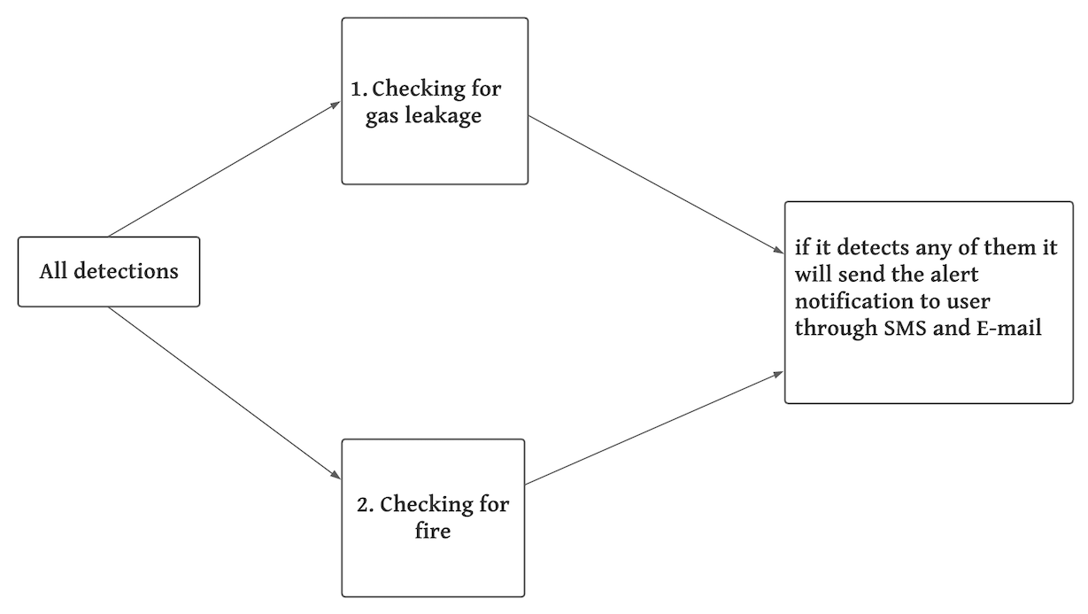

Fig 3.4.2 Detecting fire and gas leakage using sensors

**3.4.3.Alert system through SMS and E-mail:** In an IoT-based gas booking and sensor alert system, an alert system through SMS and email is an essential component of the system. The system is designed to monitor the gas level and detect any potential issues that may arise. If the gas level falls below a certain threshold, the system will trigger an alert and send a notification to the user via SMS and email.

The alert system is designed to provide real-time updates to the user, ensuring that they are aware of any potential issues with their gas supply. The SMS and email notifications provide an immediate response to the user, allowing them to take appropriate action to resolve the issue. For example, if the gas level is low, the user can book a gas refill or take other necessary measures to ensure that their gas supply is restored.

The SMS and email alert system is also useful in case of emergencies. If there is a gas leak or any other hazardous situation, the system can immediately notify the user via SMS and email, providing them with important information on how to respond to the emergency.

Overall, the alert system through SMS and email in an IoT-based gas booking and sensor alert system is a crucial component that helps to ensure the safety and reliability of the gas supply. By providing real-time updates and notifications, the system enables the user to take immediate action in case of any issues or emergencies, ensuring that their gas supply is always secure and reliable.

**3.4.4.Web page and data maintenance**

To ensure convenience for users, a web page has been created which serves as a platform to receive alerts about various types of detections such as gas levels, gas leaks and fires. The web page is designed to notify the users about any such detections as soon as they occur, to enable timely actions to be taken. Additionally, a record of all past detections is maintained in a table format on the same webpage, for the purpose of maintenance. This record provides valuable information to users about the frequency of gas leaks and fires, allowing them to prepare accordingly.

When a detection occurs, the system promptly sends out SMS and email alerts to the users' registered phone numbers and email addresses respectively. The alerts include details of the detected event, as well as a web page link that directs the users to the relevant webpage. This enables users to access the information on the website without any hassle, thereby ensuring efficient communication.

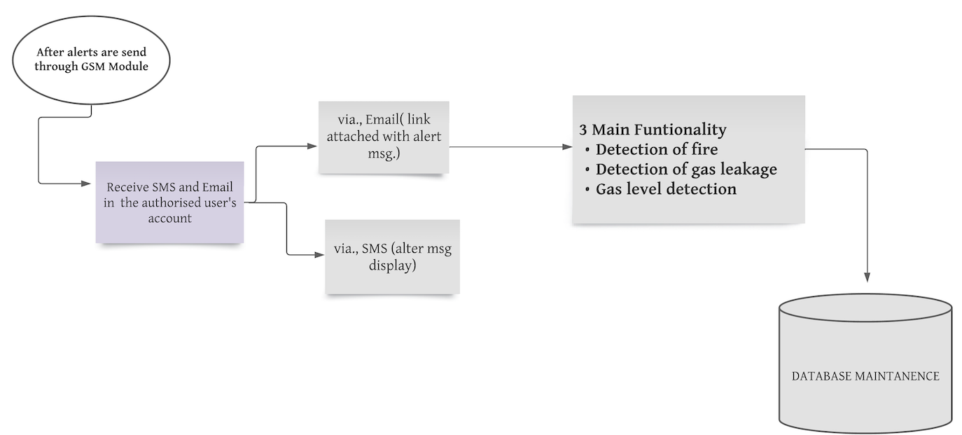

Fig 3.4.4.1 Web page and data maintenance

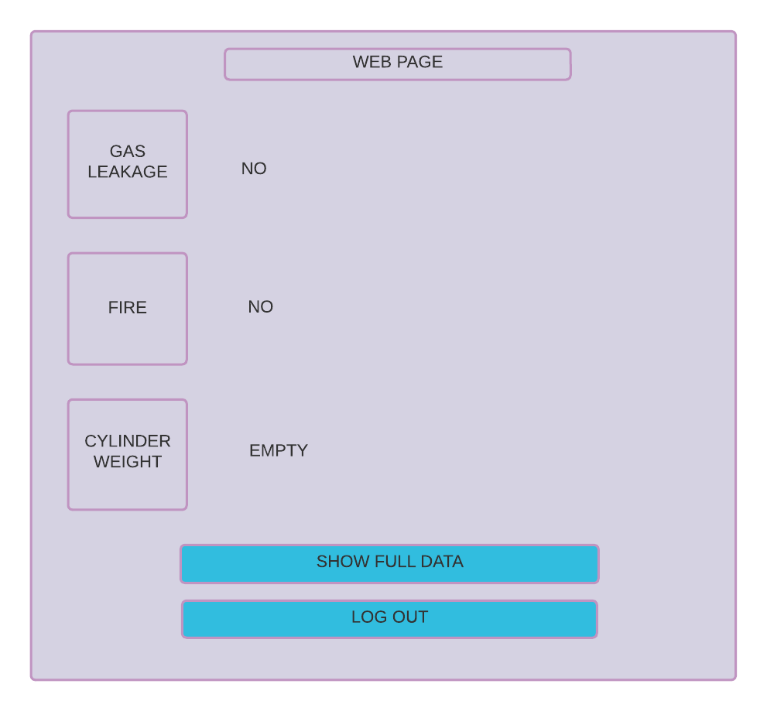

Fig 3.4.4.2 Web page and data maintenance

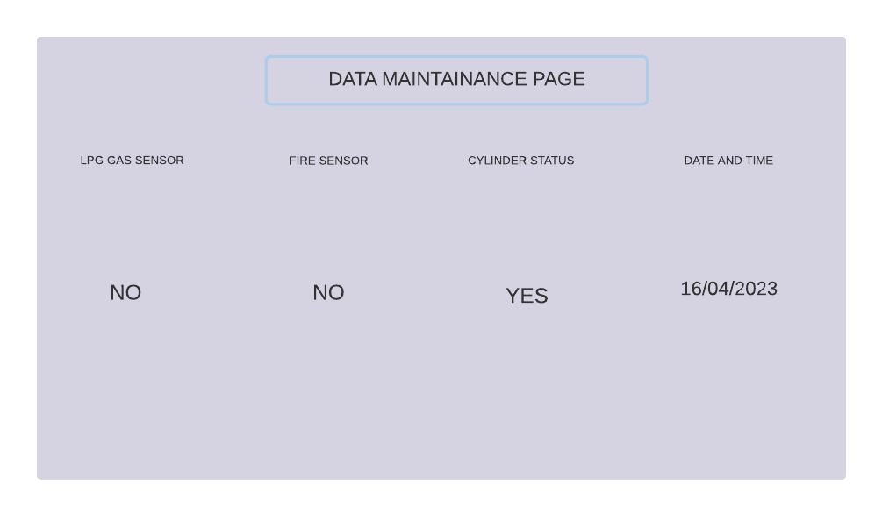

Fig 3.4.4.3 Web page and data maintenance

#### **PRODUCT IMPLEMENTATION:**

Here are few points to explain proper implementation of our project-

1. The project addresses two main issues related to the use of LPG gas cylinders: customers booking their cylinders too early or too late, and potential hazards of gas leakage caused by human error.
2. A range of electronic components were utilized in the project including the SIM 800L module, power supply board, bridge rectifier, filter capacitor, 7805 voltage regulator, MQ2 gas sensor, 16x2 LCD display, fire sensor, buzzer, MAX232 IC, level converters, HX711 module, load cell, and Arduino Uno R3.
3. Connectors, male and female cables, and other necessary components were used to ensure that the sensors were correctly connected.
4. The project provides a solution for customers who experience inconvenience or waste resources by booking their LPG gas cylinder too early or too late.
5. The project aims to prevent gas leakage caused by human error, which can be dangerous or even fatal in certain situations.
6. The SIM 800L module allows for remote monitoring and control of the gas cylinder.
7. A power supply board, bridge rectifier, and filter capacitor were employed to ensure that the electrical components were supplied with the appropriate voltage and current.
8. The 7805 voltage regulator was utilized to stabilize the voltage and prevent any potential damage to the electronic components.
9. An MQ2 gas sensor was employed to detect gas leaks, and a fire sensor to identify potential fire hazards.
10. A buzzer was used to warn users in case of any gas leaks or fire hazards.
11. A 16x2 LCD display was used to present the status of the gas cylinder, including the amount of gas remaining and the last time the cylinder was refilled.
12. A MAX232 IC and level converters were used to ensure accurate communication between the various electronic components.
13. An HX711 module and load cell were utilized to measure the weight of the gas cylinder precisely.
14. The load cell sends data to the Arduino Uno R3, which then displays the weight on the LCD display.
15. The project has the potential to improve the safety and efficiency of LPG gas cylinder usage, benefiting both customers and gas companies alike.

### **Proposed Model Outputs**

The proposed output for the IoT-based LPG gas booking and sensor alert system is as follows:

1. Real-time gas level sensing: The system provides real-time gas level readings using load sensors and Arduino UNO. The weight data is transmitted to the cloud platform through a SIM module for networking.
2. Alert system: When the weight falls below a certain limit, the user is immediately alerted through SMS and email to reserve a cylinder in advance. The system also uses a MQ2 gas sensor to detect gas concentration and alerts the user when it exceeds a preset level.
3. Gas leak detection: The system incorporates a MQ2 sensor connected to an Arduino to detect gas leaks. When a gas leak is detected, the system activates an alarm and displays an alert on the LCD screen. The system also sends SMS and email alerts to the user's registered mobile number and email address.
4. Load cell measurement: The system uses a load cell to measure the gas weight and displays the result on the LCD screen. When the cylinder's weight falls below a certain level, the system immediately alerts the user to order a replacement cylinder and sends the notification to the customer through a GSM module.

Overall, the proposed output would provide the user with a comprehensive gas monitoring and booking system that can detect gas leaks and alert the user in real-time. The system would also use load sensors to monitor the gas level and send SMS and email alerts to the user when the gas level falls below a certain threshold. The proposed system would provide a much more efficient and convenient way for users to monitor their gas usage and ensure they always have a sufficient supply of LPG gas.

**3.6 Design Templates**

Below are the snapshots of the basic layout design of our system.

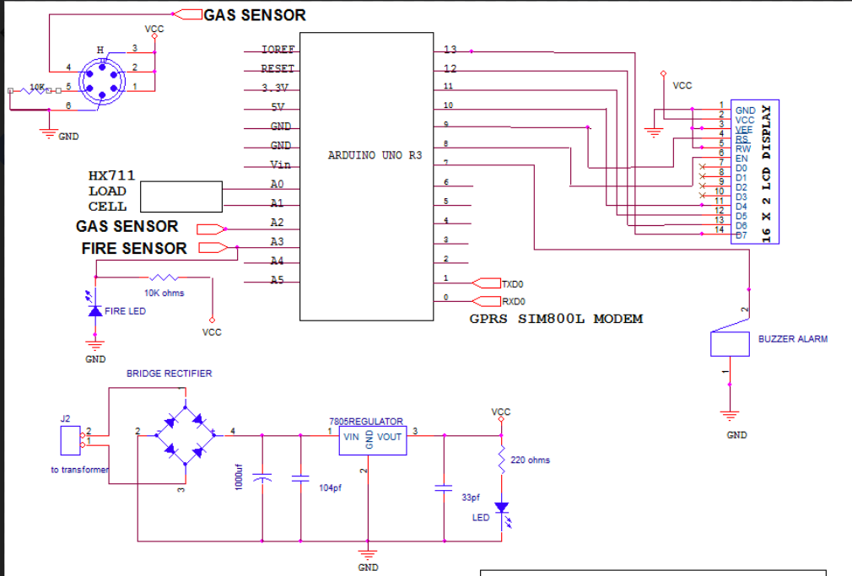

Fig 4.2. Semantic diagram

### **Components**

Below are the sample images of all the component used to make the PCB.

**Components**

|  |  |
| --- | --- |
| Components | Pictures |
| SIM 800L | OLatus OL-GSM-SIM800L GSM SIM800L GPRS GSM Module MicroSIM Card Core BOard  Quad-band Serial Port with Antenna : Amazon.in: Computers & Accessories |
| power supply board | Amazon.in: Buy Electronicspices PCB 2A 220V AC to 5V DC SMPS Power Supply  Circuit Board Online at Low Prices in India | Electronicspices Reviews &  Ratings |
| bridge rectifier | Bridge Rectifier : Circuit Diagram, Types, Working & Its Applications |
| filter capacitor | Filter Capacitor : Circuit, Working, Formula and Its Applications |
| 7805 voltage regulator | ST Single Phase 7805 Voltage Regulator, Packaging Type: 50 In 1 Strip at Rs  10 in Mumbai |
| Mq2 gas sensor | Buy MQ2 Gas Sensor Module for LPG/Smoke Detection – QuartzComponents |
| 16x2 lcd display | 16x2 LCD Display Module (Green) – QuartzComponents |
| fire sensor | IR Flame/Fire Sensor Module - Buy Fire Sensor Module at QuartzComponents.com |
| Max232 IC | MAX232 IC : Pin Configuration, Circuit, Working & Its Applications |
| busser | Alarm Buzzer at best price in Coimbatore by Unimax Technologies | ID:  6530419148 |
| Level convertors , | TXS0108E 8 Channel Bi-Directional Logic Level Converter Module |
| Hx711 module , | HX711 Load Cell Amplifier Module – QuartzComponents |
| Load cell , | Load Cell Mini 10KG Weight Sensor - |
| Arduino uno r3 | Buy Arduino Uno R3 Development Board Online – QuartzComponents |

Table 4.3.1 Component table

**3.6.1.** **Description about components and their working in our project:-**

**(1) Arduino Uno R3**

Here are the main points about the Arduino Uno board and its role in the system:

* The Arduino Uno board is the central processing unit of the system.
* It collects data from all the sensors and transfers the output to the LCD display.
* The board has six analog inputs that can convert continuous signals into digital values.
* The board is equipped with a 16 MHz ceramic resonator that provides timing to the board and a USB port for power and communication purposes.
* It has a power jack for an external power supply and an ICSP header for programming the Arduino.
* The board has 14 digital input/output pins, six of which are used for connecting various sensors as input and output, and they can also perform as PWM outputs.
* The PWM pins can produce a series of pulses that can control the brightness of LEDs, the speed of motors, and the frequency of tones.
* The Arduino Uno board is a reliable and efficient way to collect, process, and display sensor data.
* Its user-friendly interface and easy-to-use software make it an excellent choice for beginners and professionals alike.
* Overall, the Arduino Uno board is an essential component of the system, providing a versatile platform for a wide range of applications

**(2) GSM Module**

* The connection between the microcontroller and the GSM module is established using the MAX32 interface.
* The MAX32 interface enables network connectivity for the user, allowing the microcontroller to communicate with the GSM module.
* The GSM module is responsible for transmitting data to other mobile phone interfaces, acting as a gateway to the mobile network.
* A SIM card is required to enable the transmission of SMS or data.
* The GPRS feature is utilized to transfer data over a mobile network, which is a fast and reliable way to communicate with other devices.
* The MAX32 connection provides a seamless interface between the microcontroller and the GSM module, enabling the user to establish network connectivity with ease.
* The SIM card is an essential component of this setup, as it enables the user to access the mobile network and communicate with other devices.
* The GPRS feature is a popular method for transferring data over mobile networks, as it provides a fast and efficient way to communicate with other devices.
* The microcontroller's connection with the GSM module through the MAX32 interface, combined with the use of a SIM card and the GPRS feature, provides a robust platform for communication between devices.
* This setup enables the user to transmit data and communicate with other devices quickly and efficiently, making it an essential component of our system.

**(3) Gas sensor MQ2**

* Gas leak detection is important, particularly for butane and propane cylinders.
* The gas sensor MQ2 module is used to detect combustible gases by detecting changes in resistance when it comes in contact with a specific gas.
* The MQ2 sensor consists of stannic oxide, which only becomes active when combustible gas is detected and can be adjusted for sensitivity using a potentiometer.
* When the MQ2 sensor comes into contact with a gaseous element, such as butane or propane, its resistance changes, causing voltage fluctuations that the Arduino can detect.
* The MQ2 sensor, in combination with the Arduino Uno board, provides accurate and timely information about the presence of combustible gases in the environment.
* The MQ2 sensor is a reliable and effective solution for detecting gas leaks in a variety of environments due to its sensitive component and ability to interface with the Arduino Uno board.

**(4) Load Cell**

* The load cell is a device that measures force or weight and converts it into an electrical signal.
* The load cell is used in this system to accurately measure the weight of the cylinder.
* To operate the load cell, a voltage ranging from 5 to 10 volts is applied to it.
* The weight of the cylinder is determined by measuring the changes in resistance that occur when the weight is applied to the load cell.
* These changes in resistance are converted into an electrical signal, which can be used to display the weight of the cylinder on the LCD screen or transmit it to a remote location.
* The load cell is a critical component of the system as it provides accurate measurements of the cylinder's weight, ensuring safety and efficiency.
* The load cell is designed to provide precise and reliable weight measurement, commonly used in applications requiring weight or force measurement, such as industrial, agricultural, and medical applications.
* Calibration is essential to ensure the load cell operates correctly, adjusting it to provide accurate weight measurements using known weights or calibration masses.
* Regular calibration ensures that any discrepancies between the measured values and the expected values are corrected by adjusting the load cell's calibration settings.

**(5) Load Cell amplifier (HX711)**

* The HX711 IC is a load cell amplifier that amplifies the signal from the load cell to measure weight.
* The load cell is a device that converts the amount of force applied to it into an electrical signal.
* The signal from the load cell may be too weak to be effectively processed by the Arduino board.
* The HX711 IC amplifies the signal from the load cell and sends it to the Arduino for further analysis.
* The HX711 IC is a small board that is easy to install and use, connecting to the load cell and Arduino board via a simple wiring system.
* The load cell amplifier enables the Arduino to accurately determine the weight of an object placed on the load cell.
* The HX711 load cell amplifier is an important device that is popular for weight measurement applications.

**(6) LCD**

* LCD stands for liquid crystal display, which uses both liquid and solid phases of matter to create a high-quality image on the display.
* The working principle of an LCD involves blocking light to form an image on the screen, and compared to other display technologies, LCDs are more compact and take up less space.
* LCD technology is commonly used in displaying the weight of fuel content with high precision, making it useful in industries where accurate measurement is crucial, such as aviation.
* To create a clear image on an LCD, the device employs a layer of liquid crystals that block light when an electric current passes through them.
* The number of liquid crystal pixels on the screen determines the image's resolution.
* LCDs are known for their compact design, low energy consumption, and precise measurements, making them suitable for various industries and applications, including consumer electronics, aviation, healthcare, and more.

**(7) Fire Sensor**

* An Arduino microcontroller board is connected to a fire sensor that detects changes in temperature.
* The fire sensor works by measuring the temperature of its surroundings and identifies the presence of fire.
* When the sensor detects the presence of fire, the Arduino processes the data and sends an alert to the user through a predefined communication channel like email or text message.
* The alert is also displayed on an LCD screen in real-time, allowing the user to identify the source of the alert and take appropriate action.
* The use of an LCD screen enables continuous monitoring of the sensor, ensuring that the user is always aware of any changes in the surrounding environment.
* The combination of a fire sensor, Arduino, and LCD screen creates a reliable and efficient system for detecting and alerting users to the presence of fire.
* The system is easily customizable to suit different environments and requirements, making it suitable for a wide range of applications, including home security and industrial settings.

**CHAPTER 4**

**RESULT AND OUTPUT**

As previously discussed, all techniques and discoveries have been implemented into our final product. The project report yields four conclusions:

1. Sample outputs demonstrate the model's functionality.

(ii) The user only needs to interact with the system once to turn it on.

(iii) The figure below shows an example of how the model's sensors integrate and function together.

(iv) Finally, the model's execution can be utilized for conserving LPG gas and home automation.

Top of Form

Bottom of Form

### **. Final products snapshots**

Below are the snapshots of the final product.

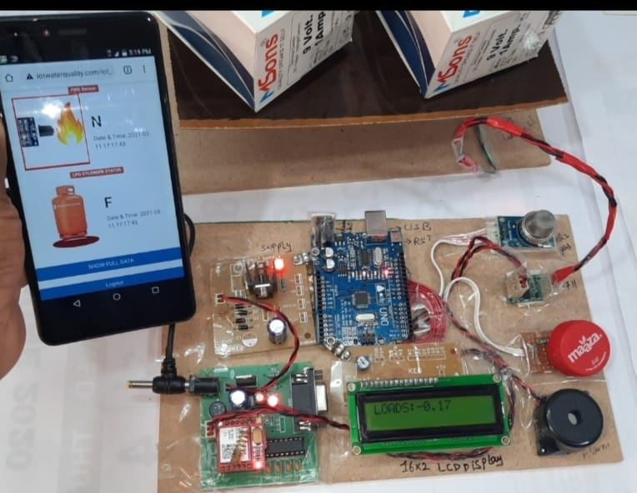

Fig 4.4.1 Final output

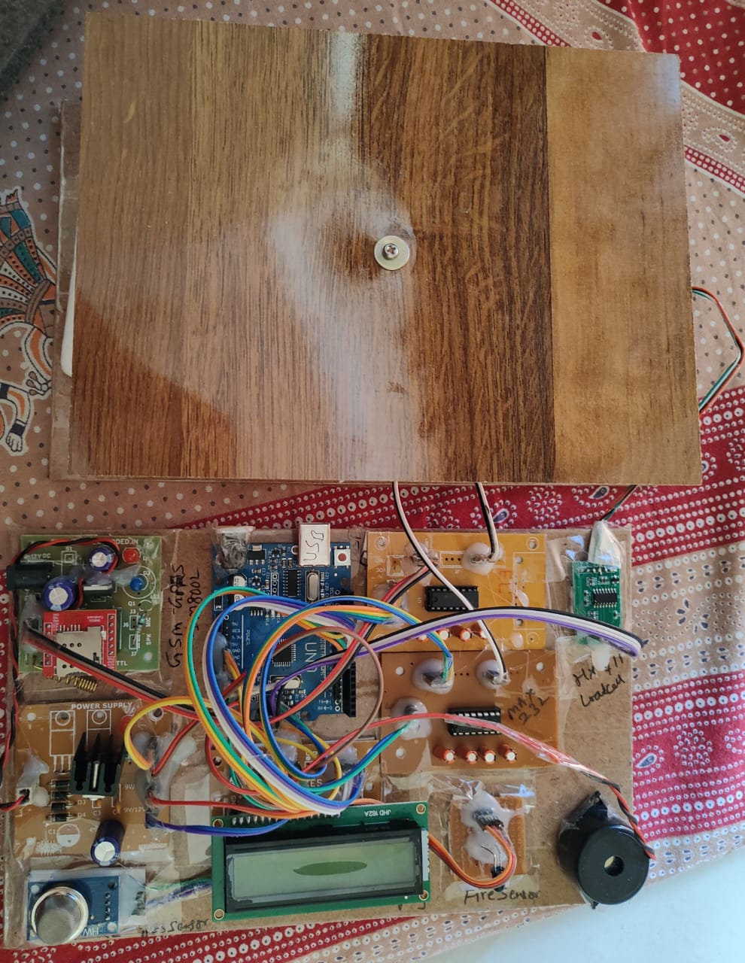

Fig 4.4.2 Final output

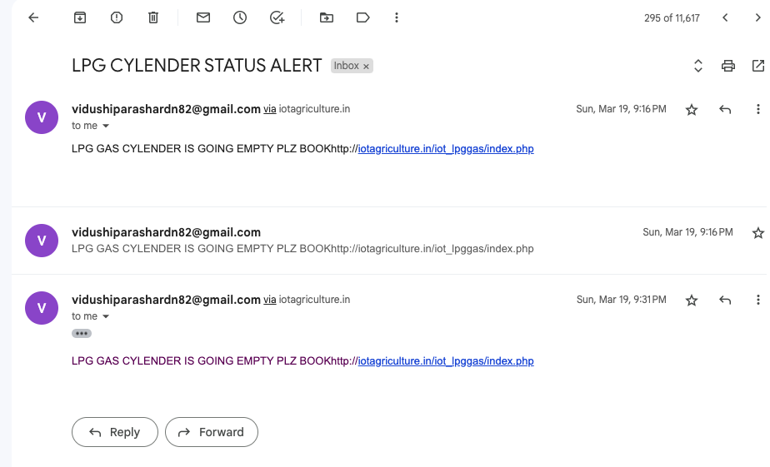

Fig 4.4.3 E-mail alert

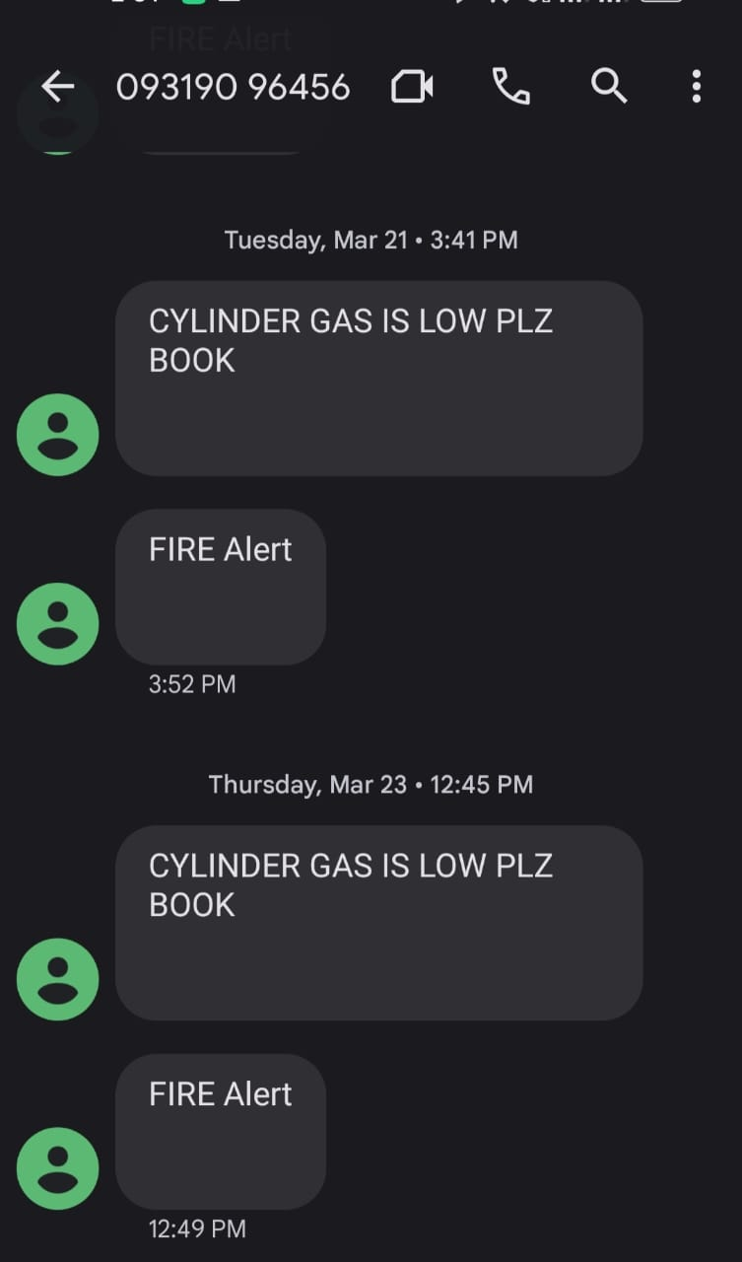

Fig 4.4.4 SMS alert

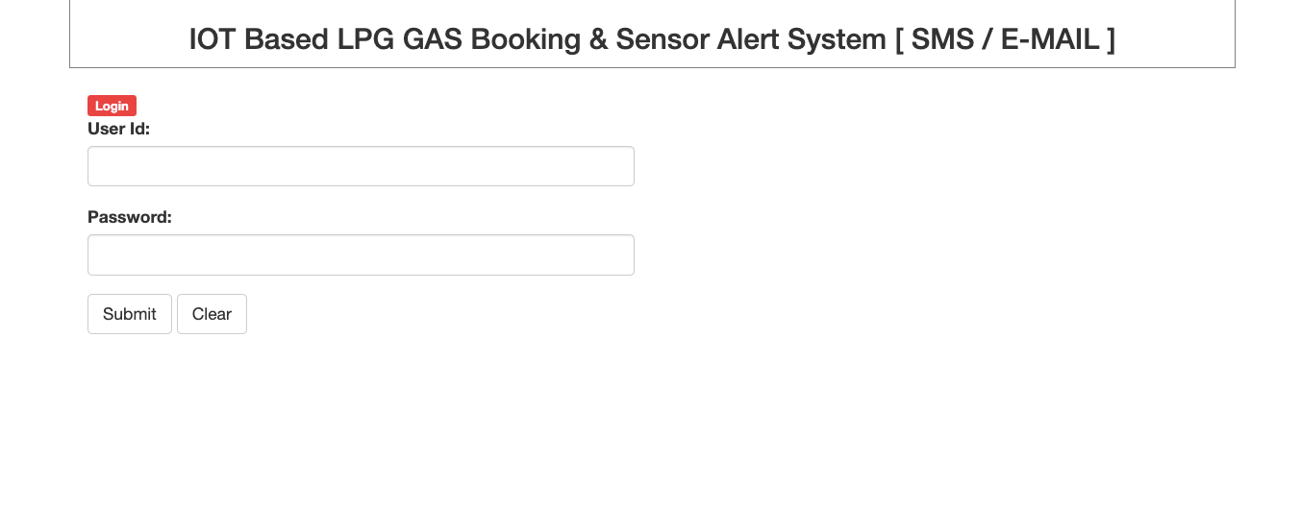

Fig 4.4.5 Web page login

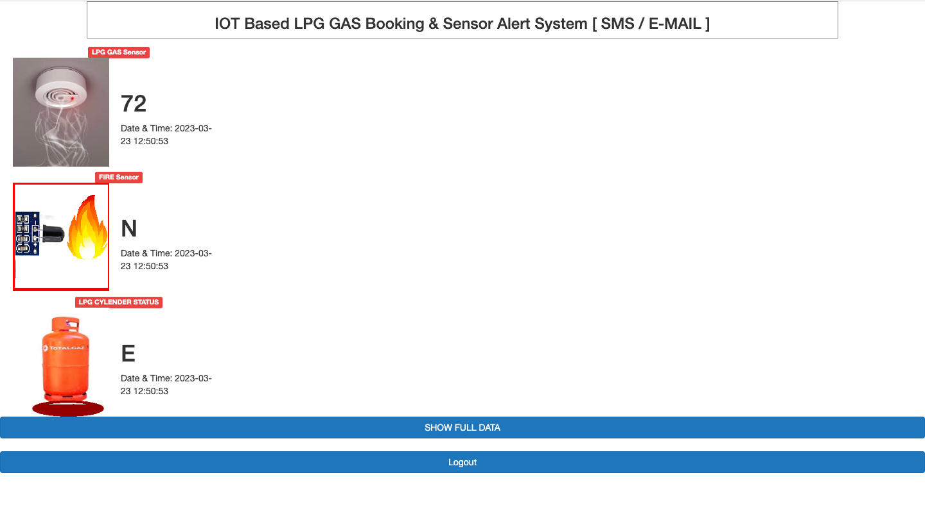

Fig 4.4.6 Web alert

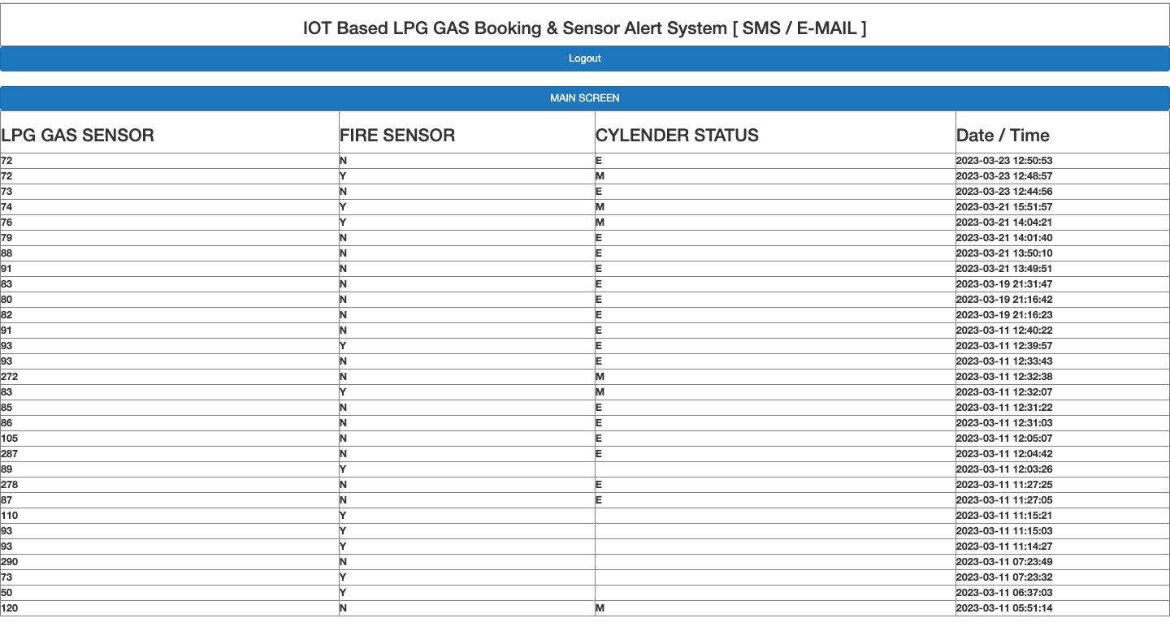

Fig 4.4.7 Web page data

**CHAPTER 5**

**CONCLUSION**

The proposed approach aims to address the challenges associated with LPG gas usage, particularly running out of gas while cooking. To solve this issue, a cost-effective gas level detection system that employs IoT technology has been proposed. This system can accurately detect the gas level, identify any fire or gas leakage, and send notifications to the user via SMS and email.

Recognizing the problems and difficulties associated with running out of gas during cooking, it was crucial to develop a straightforward and efficient solution to tackle the issue. The proposed system offers several advantages. Firstly, it helps users avoid inconvenience caused by delays in cylinder booking. By continuously monitoring the gas level, the system can send timely alerts when the level is low, allowing the user to order a new cylinder without delay. This eliminates the need to rush out to purchase a new cylinder or wait for a refill, which can be very inconvenient.

Furthermore, the proposed system helps to prevent wastage of LPG gas. By accurately detecting the gas level, the user can avoid overfilling the cylinder or using the gas unnecessarily. This not only saves money but also helps to reduce the environmental impact of LPG gas usage. The proposed system offers an efficient and eco-friendly way of managing gas usage.

Overall, the proposed gas level detection system is a simple and efficient solution to the problems associated with LPG gas usage. It offers significant benefits to users, including avoiding inconvenience, reducing wastage, and improving safety by detecting gas leakage and fire hazards. The system ensures that users can cook without interruptions and eliminates the need for them to frequently check the gas level manually. It also ensures that they can avoid wastage and contribute to environmental sustainability.

In conclusion, the proposed approach provides a cost-effective and efficient solution to the problems associated with LPG gas usage. The system's ability to accurately detect the gas level, identify any fire or gas leakage, and send notifications to the user via SMS and email ensures that users can avoid inconvenience and wastage. The proposed system also promotes environmental sustainability by preventing the unnecessary use of LPG gas. Overall, this innovative approach is a valuable addition to LPG gas usage management systems and will greatly benefit users.

### **System Usability**

The system consists of three main features, viz. measuring the weight of gas cylinder, detecting any gas leakage or fire and sending alert through SMS and E-mail to the user. The IoT-based gas booking and sensor alert system through SMS and email completely takes care of the user to keep an eye on the gas level of cylinder . As all the functions once the console is switched on is taken care of by the system.

As soon as the user switches on the module the system checks for all the modules inside it are working properly or not and afterward it send signal to the gas level detector sensor and receive signal if the gas level is low it also checks for any gas leakage or fire around.

Therefore, overall, it brings out an excellent application for all the places where LPG gas cylinders are used. It can be fitted anywhere in households, factories, Industries etc. The whole product has been made market ready at a very cost efficient price so that a common man can easily afford it for their households.

Thus, the system brings out a real-time, one-to-one experience for all the users, so that they can enjoy and make their home futuristic by adding these automated functions in their homes. Not only the user is automating their homes they are also one step towards saving wastage of LPG gas and avoid delay booking of cylinders in a parallel manner.

* 1. **Future Scope**

The final product implementation has the potential to serve beyond its original purpose and be applied in various settings such as factories and industries. By incorporating a pre-recorded voice system, the product can notify the user of any detection by placing a phone call and playing the pre-recorded audio message.

Furthermore, a system could be designed to enable the device to automatically contact the fire department in the event of a fire detection. This added functionality would increase the level of safety and security for users and could potentially reduce the risk of damage and harm. The product's adaptability and additional features make it versatile and valuable for various scenarios and settings beyond its initial intended use. It can be a useful tool to enhance safety measures in places where fire hazards are common, providing a reliable and quick response to potential threats.

**REFERENCES**

|  |  |
| --- | --- |
| [1] | M. A. D. P. Mr. Akshay D. Prabhu, “Gas Leak Detector using Arduino UNO Microcontroller,” *International Journal for Research in Applied Science & Engineering Technology (IJRASET),* vol. Volume 5 Issue VII, July 2017. |
| [2] | J. N. A.-K. A. E. Kamal, “Routing Techniques in Wireless Sensor Networks: A Survey,” *IEEE Wireless Communications ,* January 2005. |
| [3] | D. D. J. S. J. D. R. S. Tanvira Ismail, “GSM Based Gas Leakage Warning System,” *International Journal of Advanced Research in Computer and Communication Engineering,* 4, April 2014. |
| [4] | K. Keshamoni and S. Hemanth, “Smart Gas Level Monitoring, Booking & Gas Leakage Detector over IoT,” *IEEE,* 2017. |
| [5] | D. A. A. G. S. B. A. H. D. E. Jebamalar Leavline, “LPG Gas Leakage Detection and Alert System,” *International Journal of Electronics Engineering Research.,* Number 7 2017. |
| [6] | M. M. Khan, “Sensor-Based Gas Leakage Detector System,” *7th Electronic Conference on Sensors and Applications,* 14 November 2020. |
| [7] | R. T. N. N. E. M. A. MAHALINGAM, “Design and Implementation of an Economic Gas Leakage Detector,” *6th International Conference on Circuits, Systems and Signals,* March 2012. |
| [8] | J. A. G. D. P. S. K. k. T.Soundarya, “C-Leakage: Cylinder LPG Gas Leakage Detection for Home Safety,” *IOSR Journal of Electronics and Communication Engineering (IOSR-JECE),* Feb. 2014. |
| [9] | I. S. Pal-Stefan Murvaya, “A survey on gas leak detection and localization techniques,” *Journal of Loss Prevention in the Process I ndustries,* November 2012. |
| [10] | M. J. W. S. M. a. R. A. Rafik GHALI, “Recent advances in fire detection and monitoring systems: A review,” *Research Gate,* January 2020. |
| [11] | A. S. S. B. V. K. U. A. S. K. Vasudev Yadav, “A Review on Microcontroller based LPG Gas Leakage Detector,” *Journal of VLSI Design and Signal Processing.* |
| [12] | O. A. ,. A. O. Yekini Nureni, “Gas Leakage Detector and Monitoring System,” *International Journal of Engineering and Manufacturing,* june 2022. |
| [13] | M. Z. U. Q. N. M. Rahul Kathuria, “Protection from Leakages of Gas from LPG Cylinders,” *International Journal of Engineering Research & Technology (IJERT),* 2014. |
| [14] | M. A. D. P. Mr. Akshay D. Prabhu, “Gas Leak Detector using Arduino UNO Microcontroller,” *International Journal for Research in Applied Science & Engineering Technology,* 2017. |
| [15] | J. N. A.-K. A. E. Kamal, “Routing Techniques in Wireless Sensor Networks: A Survey,” *IEEE,* 2004. |

**ANNEXURE I**

A design patent for the said project has been **registered** to design a gas regulator **in Indian patent the government of India. Design number- 376195-001.**

**Title:** **IOT BASED GASBOOKING AND SENSOR ALERT SYSTEM THROUGH SMS AND E-MAIL.**

#### **Abstract:**

Recently, technology advancements have greatly improved daily life in many ways, with LPG being widely used for cooking. However, people often face issues such as running out of gas during meal preparation, not knowing how much fuel is left, and not being able to predict when the cylinder will run out. To address these problems, the Smart Gas Kit has been developed. This kit leverages IoT to monitor and display the amount of gas in a household LPG cylinder. It also predicts the remaining life of the gas. The system constantly measures the gas level using a load cell connected to a microcontroller, and sends notifications to the user via their mobile phone. The aim of the system is to make the LPG reservation process more automated and hassle-free.

#### **Authors:**

Dr. Vivek Sharma , Dr. Shree Harsh Attri , Mr. Abha Kaushik , Mr. Ravi Shankar , Ms. Tanya Bhadouria , Ms. Vidushi Parashar

